Matching Game:
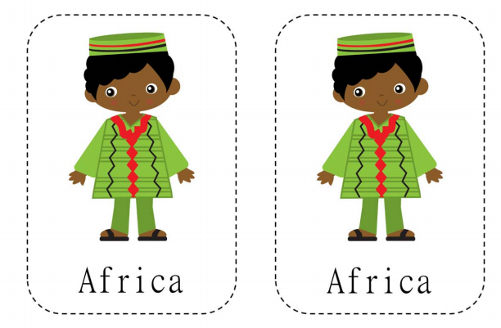
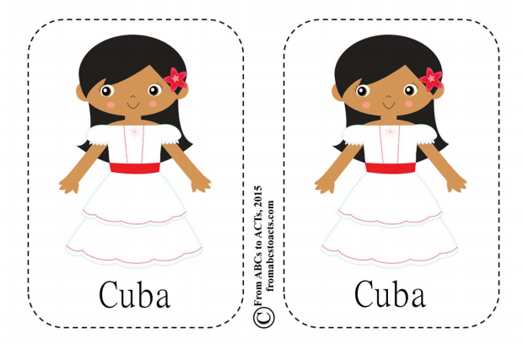

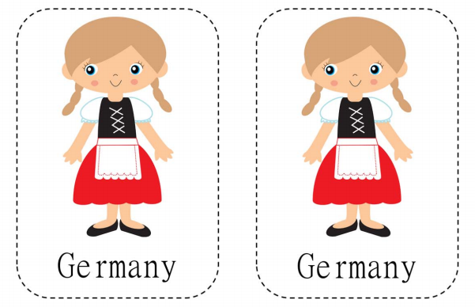
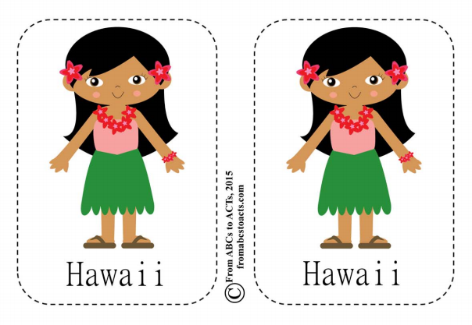
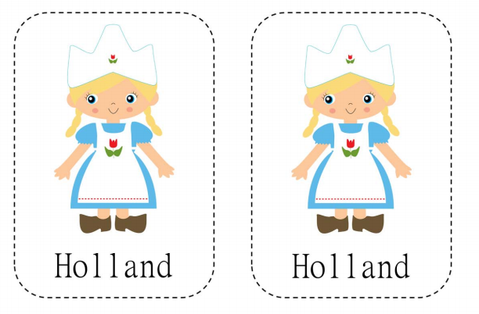
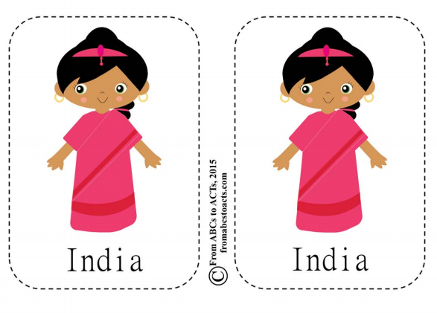

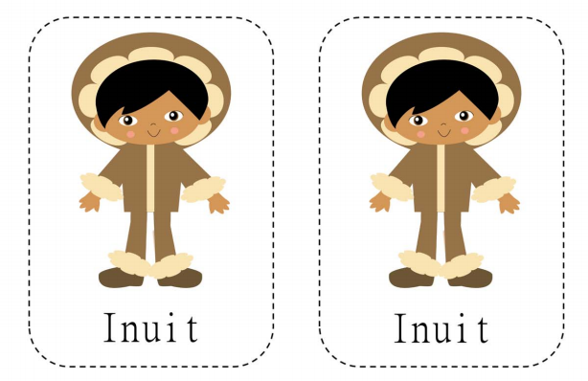
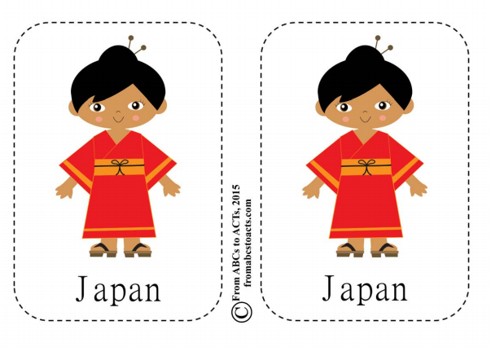

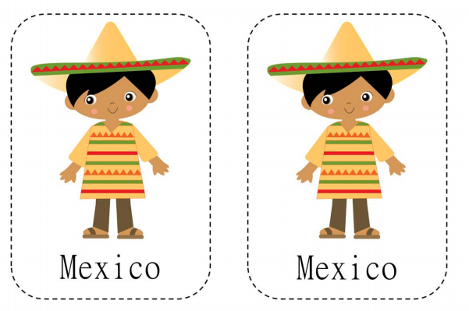
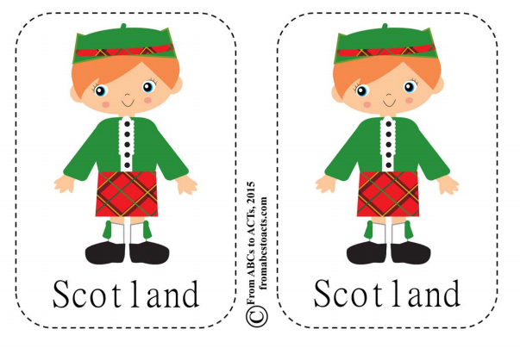

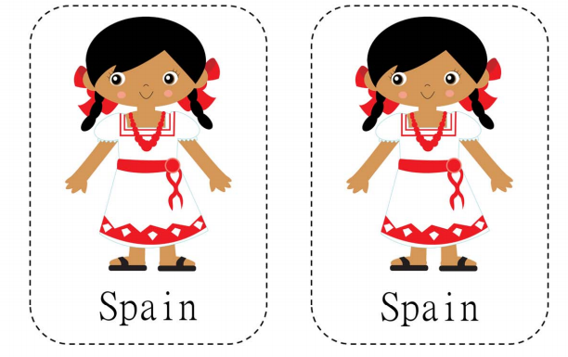
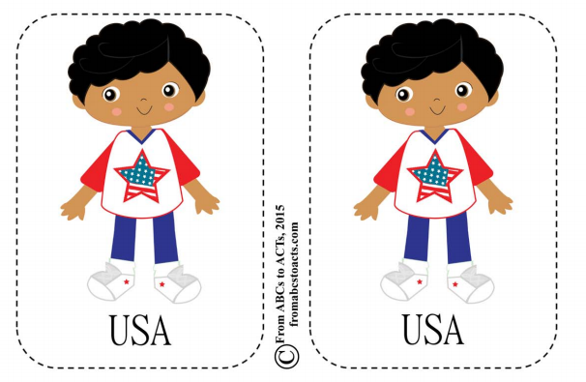

LetterA & X Handwriting Practice:
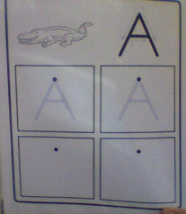

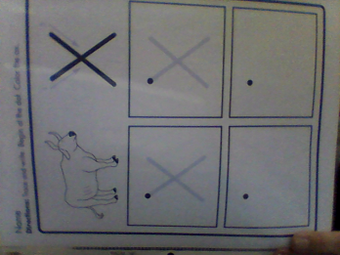

Math Lesson 9:
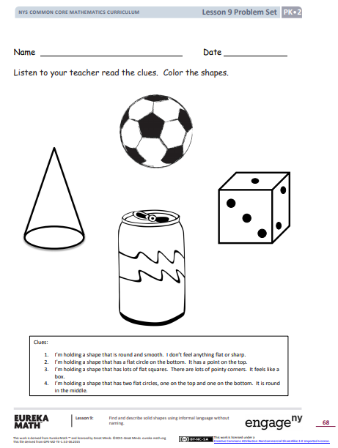

Look at the clothing from around the world. Decorate the outline with an outfit of your choice! Use materials from around your house or color it!

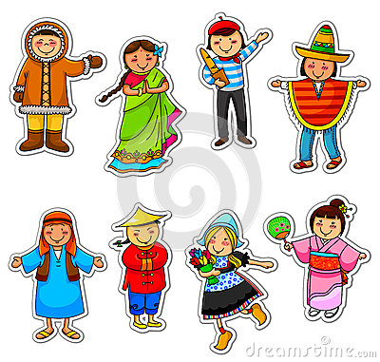

Letter Y Practice:
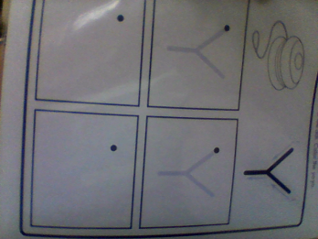

Letter Z Practice:

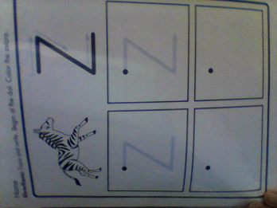

This is my world…

Math Family Newsletter:
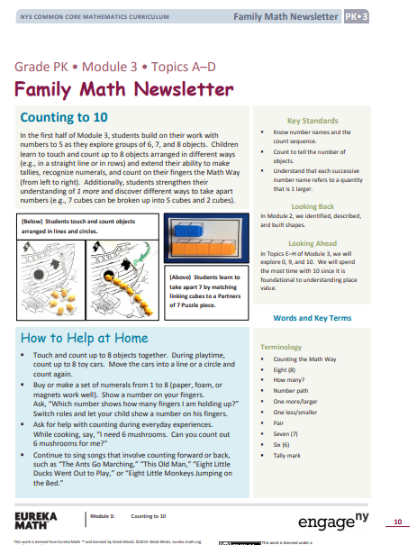

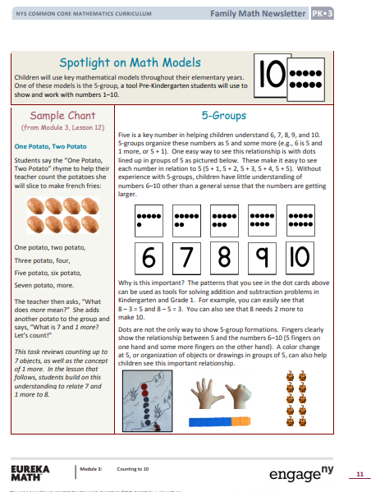

Math Lesson 1:
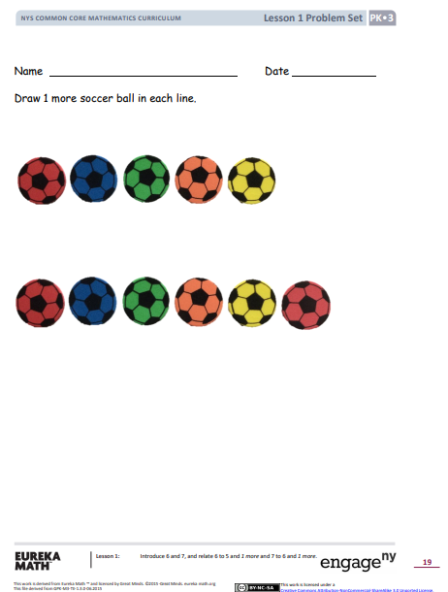

Math Lesson 5:
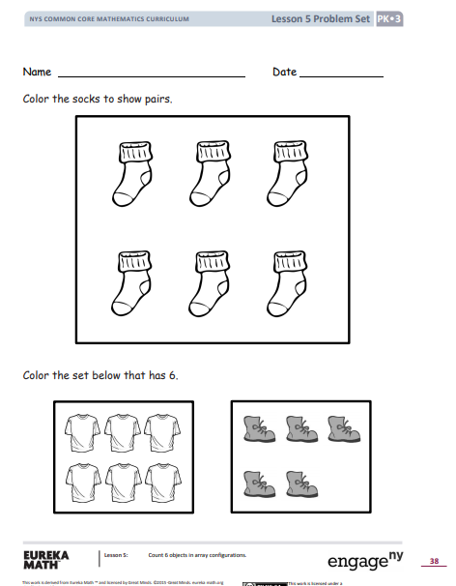

Landmark STEM ideas:
Watch the video to see landmarks from around the world. See if you can build them from items and materials around the house (blocks, cups, straws, empty toilet paper tubes, legos, anything)!
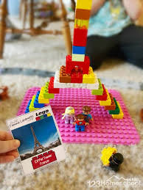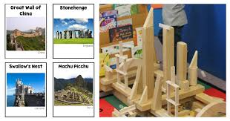
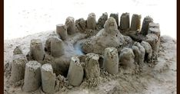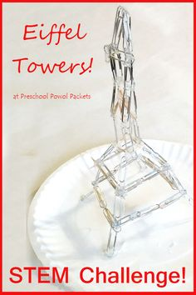

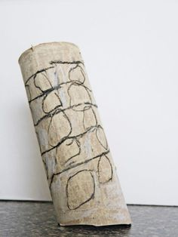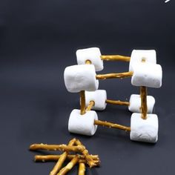
Practice writing the letter U:
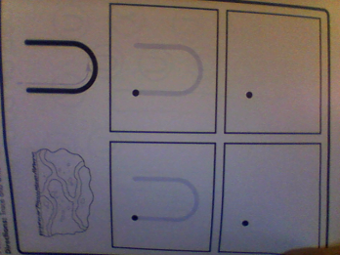

Practice writing the letter J:
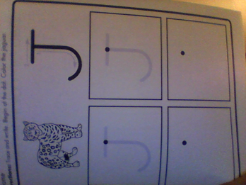

My Family Tradition

Math 6 & 7 Puzzles:
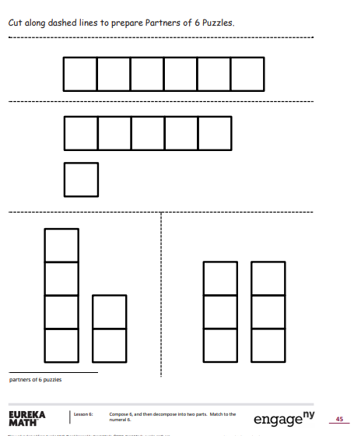

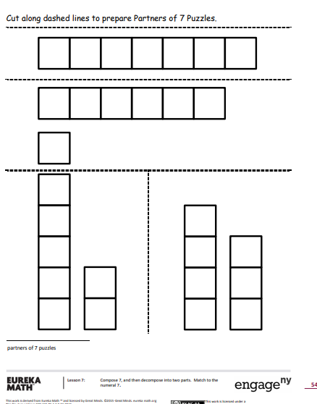

Math Lesson 8:
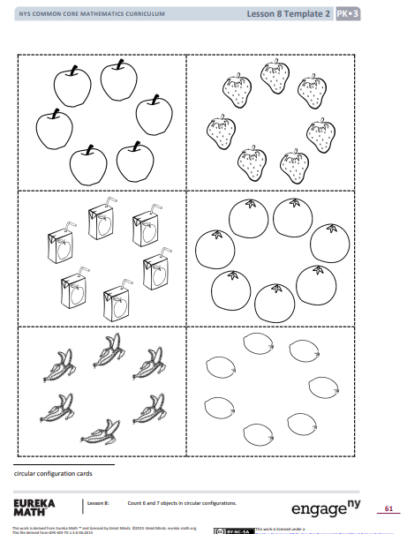

Math Lesson 9:
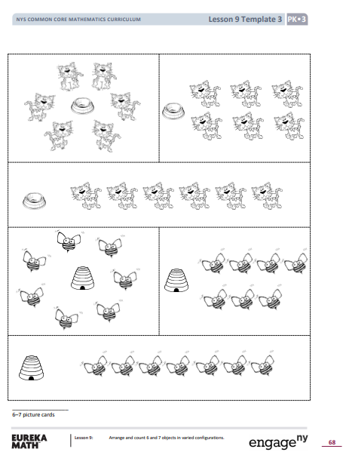

Math Lesson 10:
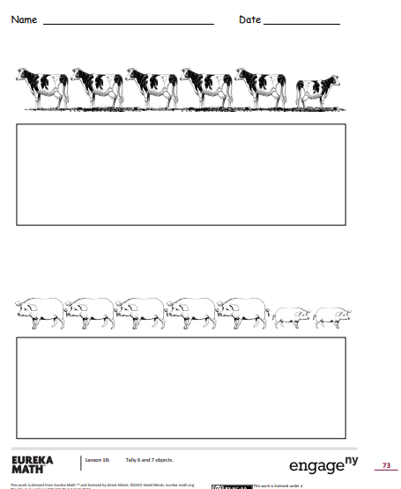

Christmas in Holland:
In the United States,Santa Claus sometimes fills children's stockings with treats. In the Netherlands, children set out their wooden shoes instead of their socks.
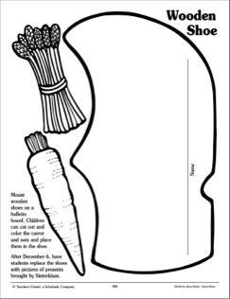

Christmas in Mexico:
- Posada Pinata
- 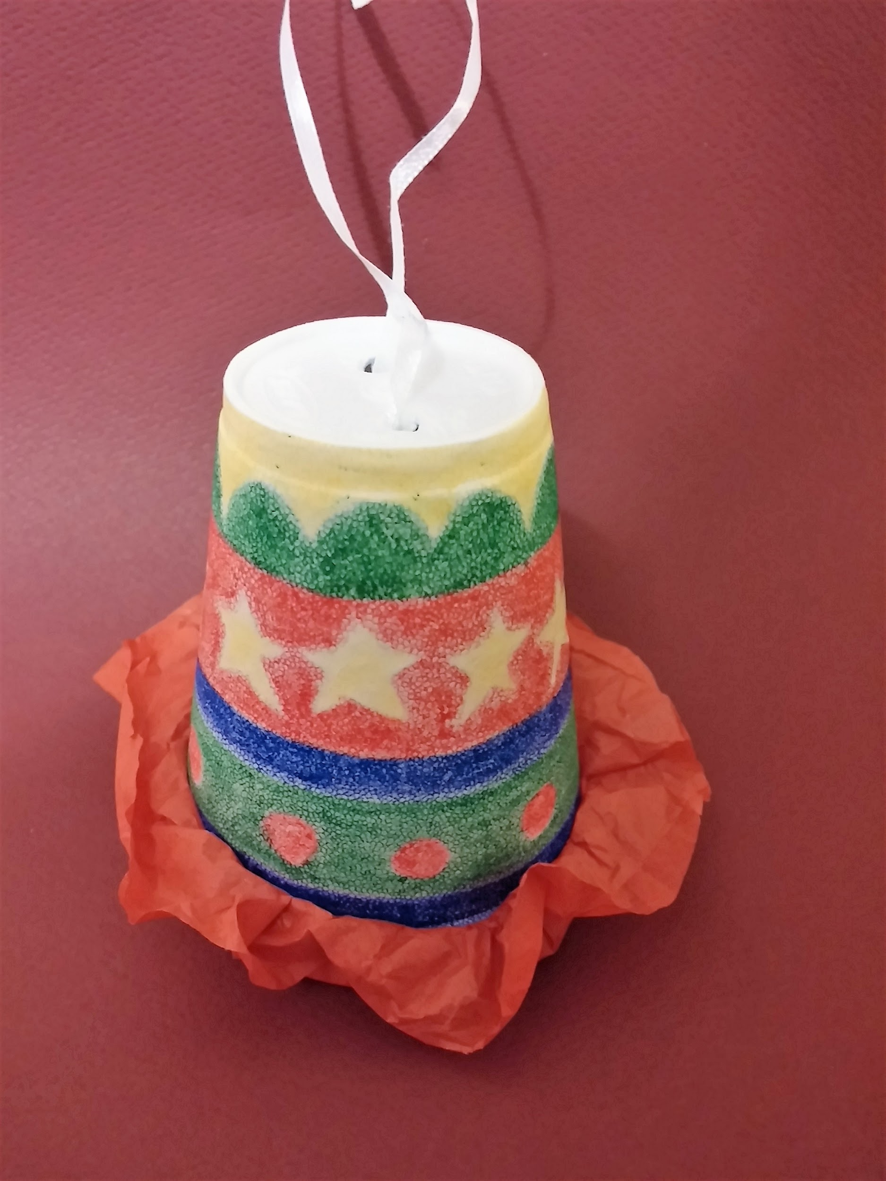
- Materials:
  - Styrofoam cup
  - Crayons
  - Pencil
  - String/ribbon
  - Candies
  - Scissors
  - Tissue paper
  - Rubber band
- How to Make it:
  - Use crayons to decorate the outside of your upside down foam cup. Don’t try to use markers — they rub off of the cup’s surface and leave you with a class full of brightly colored fingers. Encourage your students to include designs that represent the Mexican culture and celebration of Las Posadas, such as stars, Mary and Joseph, angels, etc.
  - Use your pencil to poke two holes in the bottom of your cup.
  - Thread your string/ribbon through the two holes and tie at the top so you can hang your piÃÂ±ata.
  - Fill the cup with candy (guaranteed to be your students’ favorite part!)
  - Cut a tissue paper circle about an inch larger in circumference than your cup. Place the circle over the opening of the cup and secure it with the rubber band. This keeps the candy inside the pinata until you are ready to break it open!
- For more info, visit: https://www.scholastic.com/teachers/blog-posts/amanda-nehring/las-posadas-cultural-christmas-classroom/

Christmas in Sweden:
These woven hearts are commonly hung on Christmas trees.
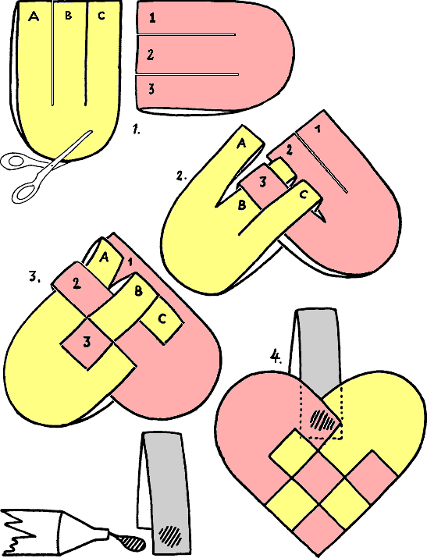

Christmas in France:
Make a Yule Log
Use an empty toilet paper tube and paper to craft a log and candles.
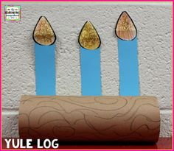

I celebrate Christmas by...

